Q1. What are the benefits of the built-in array package, if any?

Ans: **the built in arrays can grow dynamically as oppose to numpy arrays.**

Q2. What are some of the array package's limitations?

Ans: **two main packages are used to create arrays: first being array package and the other one being Numpy package. The array package doesn’t allow you to perform operations on the arrays therefore, Numpy package is used more often due to the fact it is more sophisticated.**

Q3. Describe the main differences between the array and numpy packages.

Ans: **Array packages is good for creating simple arrays but when it comes to performing calculation on the arrays, Numpy package is proven to be effective as it provides a plethora of functions for calculations.**

Q4. Explain the distinctions between the empty, ones, and zeros functions.

Ans: **np.empty() = it is used to give random and uninitialized values. Later, you can assign values to the array using a for loop.**

**Np.ones() = all values are 1**

**Np.zeros()= all values are 0**

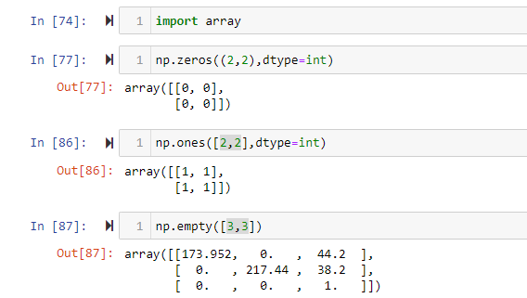

Q5. In the fromfunction function, which is used to construct new arrays, what is the role of the callable argument?

Ans: **The function is callable here which helps create an array of a given shape.**

Q6. What happens when a numpy array is combined with a single-value operand (a scalar, such as an int or a floating-point value) through addition, as in the expression A + n?

Ans: **the values gets added to all the elements to the array.**

Q7. Can array-to-scalar operations use combined operation-assign operators (such as += or *=)? What is the outcome?

Ans: **the result will be the same as the last question.**

Q8. Does a numpy array contain fixed-length strings? What happens if you allocate a longer string to one of these arrays?

Ans:

**The dtype of any numpy array containing string values is the maximum length of any string present in the array. Once set, it will only be able to store new string having length not more than the maximum length at the time of the creation.**

Q9. What happens when you combine two numpy arrays using an operation like addition (+) or multiplication (*)? What are the conditions for combining two numpy arrays?

Ans: **The shape of both arrays must be the same for these operations**

Q10. What is the best way to use a Boolean array to mask another array?

Ans:

***numpy.ma.masked_where(condition, arr)***

***numpy.ma.getmask(arr)***

***numpy.ma.masked_array(arr, mask=)***

***where,***

***condition: condition for masking***

***arr: arr to be masked***

***mask: result of masked array***

Q11. What are three different ways to get the standard deviation of a wide collection of data using both standard Python and its packages? Sort the three of them by how quickly they execute.

Ans:

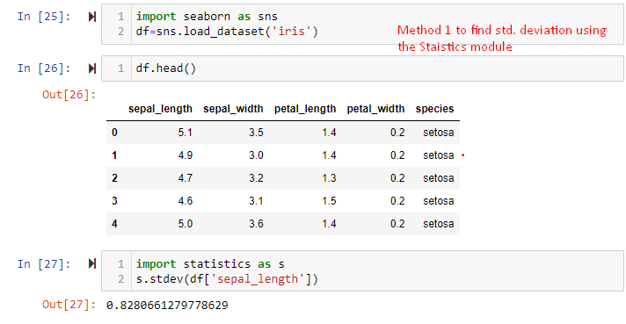

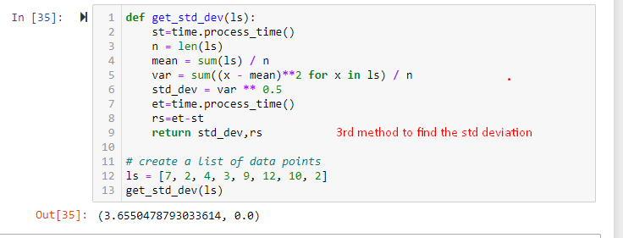

12. What is the dimensionality of a Boolean mask-generated array?

Ans: **1-D**